

Industrial Managed Ethernet Switch
Hardware User Manual

RPT-1005-X4 Series
Subject Link Inc www.sbjlink.com
sales@sbjlink.com

FCC Notice
This equipment has been tested and found to comply with the limits for a Class-A digital device, pursuant to Part 15 of the FCC rules. These limits are designed to provide reasonable protection against harmful interference in a residential installation. This equipment generates, uses, and can radiate radio frequency energy. It may cause harmful interference to radio communications if the equipment is not installed and used in accordance with the instructions. However, there is no guarantee that interference will not occur in a particular installation. If this equipment does cause harmful interference to radio or television reception, which can be determined by turning the equipment off and on, the user is encouraged to try to correct the interference by one or more of the following measures:
- Reorient or relocate the receiving antenna.
- Increase the separation between the equipment and receiver.
- Connect the equipment into an outlet on a circuit different from that to which the receiver is connected.
- Consult the dealer or an experienced radio/TV technician for help.

Caution: Any changes or modifications not expressly approved by the grantee of this device could void the user's authority to operate the equipment.

CE Mark Warning
This is a Class-A product. In a domestic environment this product may cause radio interference in which case the user may be required to take adequate measures.

Contents

Overview 1
Key Features 1
Package Contents 2
Safety Precaution 2
Hardware Description 3
Physical Dimensions 3
Front Panel 4
Top View 4
LED Indicators 5
Ethernet Ports 6
Cabling 7
Wiring the Power Inputs 7
Wiring the Fault Alarm Contact 8
Mounting Installation 9
DIN-Rail Mounting 9
Wall Mounting 11
Hardware Installation 12
Installation Steps 12
Trouble Shooting 13

Overview
This series is rated IP30 and installation by DIN Rail. Each unit of this industrial gigabit unmanaged Ethernet switch series has 5*10/100Tx Fast Ethernet ports, which the RJ-45 interface provides auto detection of MDI or MDI-X.
In order to prevent unregulated voltage, this series provides high EFT and ESD protection. This also allows it to function in harsh environments, as well as support power redundancy with a dual power input design with reverse polarity protection. The built-in relay warning function alerts users about occurring power failures.
With one model having an operating temperature of -10°C ~ 65°C, and another with a wide operating temperature of -40°C ~ 75°C, this series is designed to meet any needs for industrial automation application and harsh environments.

Key Features
Interface & Performance
- All Copper ports support auto MDI/MDI-X function
- Embedded 5*10/100Tx Fast Ethernet
- Store-and-forward switching architecture
- 2K MAC Address Table
- 448Kbits memory buffer
Power Input
- Redundant power DC 12-48V with connective 1*6-pin removable terminal bloc
- Max. current 3.5A
- Relay Contact: 24VDC, 1A resistive
Certification
- CE/FCC
- ISA 12.12.01
Operating Temperature
- Standard operating temperature model: -10°C ~ 65°C
- Extended operating temperature model (–T): -40°C ~ 75°C
Case/Installation
- IP30 protection
- Installation in pollution degree to environment
- DIN-Rail and Wall mount design

Package Contents
- 1 – RPT-1005(-T)-X4
- 2 - Wall mounting brackets and screws

Safety Precaution
Attention
If the DC voltage is supplied by an external circuit, please use a protection device on the power supply input. Supply by UL Listed industrial use power. The industrial Ethernet switch’s hardware specs, ports, cabling information, and wiring installation will be described within this user manual.

Hardware Description

Physical Dimensions
Figure 2.1, below, shows the physical dimensions

(W x H x D) is 30mm x 140mm x 95mm
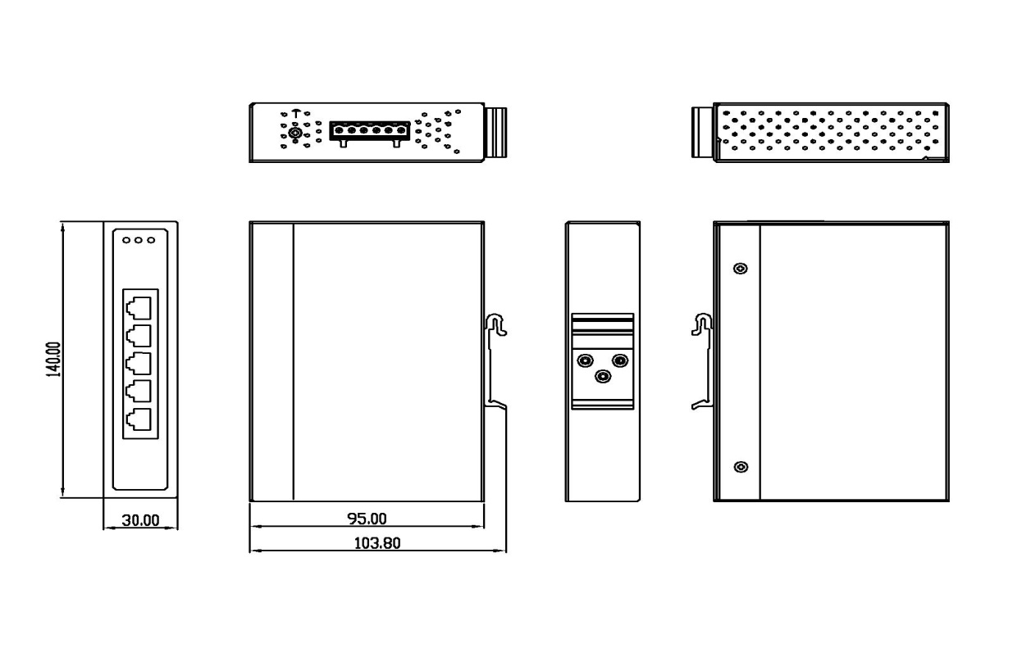
Figure 2.1: RPT-1005-X4 Series Physical Dimensions

Front Panel
The front panel of the RPT-1005-X4 series industrial gigabit unmanaged Ethernet switch is shown below in Figure 2.2.
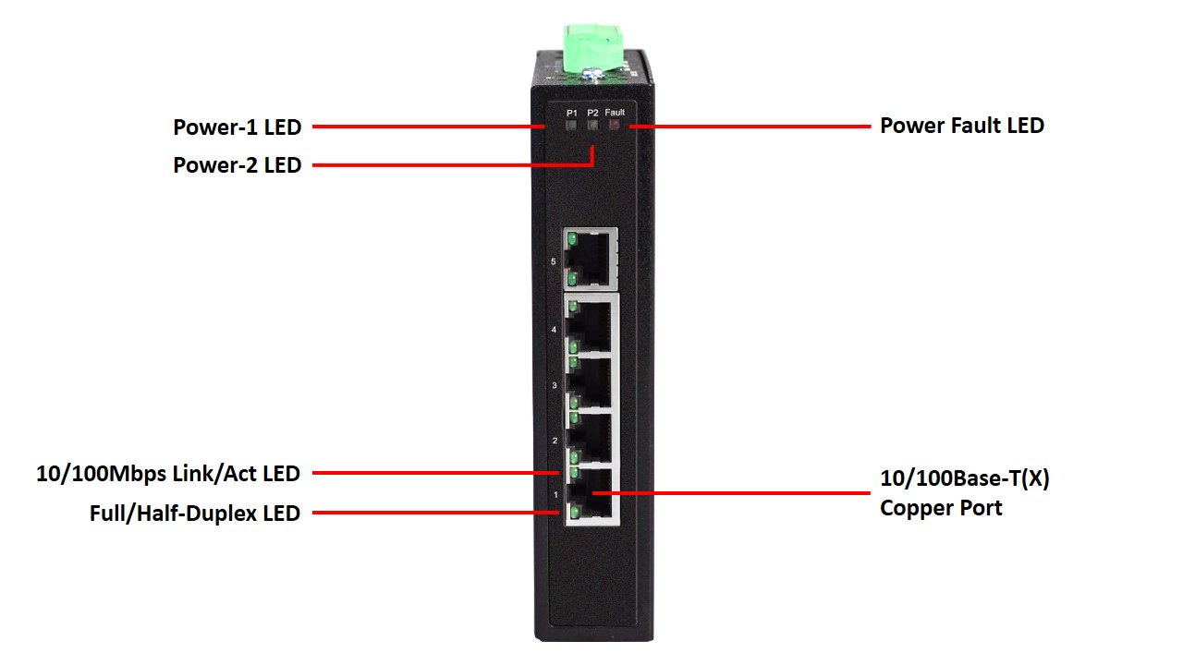
Figure 2.2: The Front Panel of RPT-1005-X4 Series

Top View
Figure 2.3, below, shows the top panel of the RPT-1005-X4 series switches that is equipped with one 6-pin removal terminal block connector for dual DC power inputs (12-48VDC).

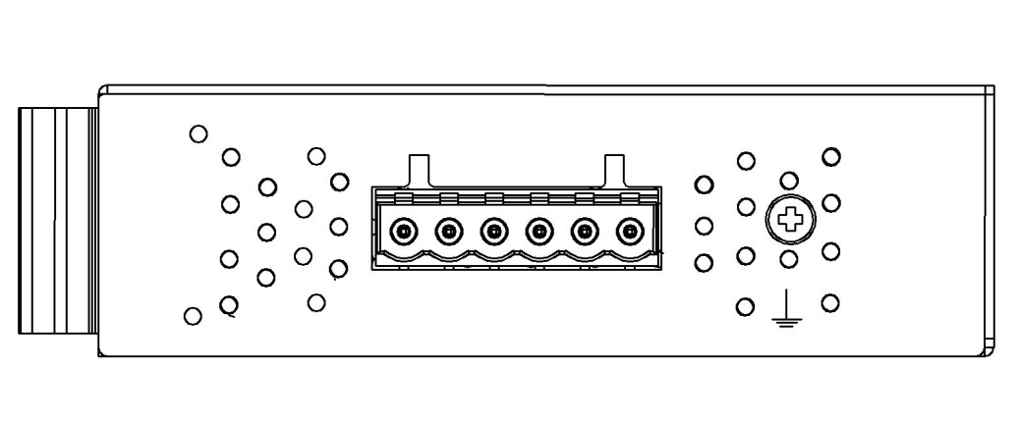
Figure 2.3: Top Panel View of RPT-1005-X4 Series

LED Indicators
There are LED light indicators located on the front panel of the industrial Ethernet switch that display the power status and network status. Each LED indicator has a different color and has its own specific meaning, see below in Table 2.1.
LED | Color | Description
P1 | Green | On | Power input 1 is active
P1 | Green | Off | Power input 1 is inactive
P2 | Green | On | Power input 2 is active
P2 | Green | Off | Power input 2 is inactive
Fault | Red | On | Power input 1 or 2 is inactive
Fault | Red | Off | Power input 1 and 2 are both functional
LAN Port  LINK/ACT/SPEED | Green  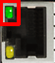 | On | Connected to network
LAN Port  LINK/ACT/SPEED |  | Flashing | Networking is active
LAN Port  LINK/ACT/SPEED |  | Off | Not connected to network
LAN Port  LINK/ACT/SPEED | Amber  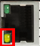 | On | Ethernet port full duplex
LAN Port  LINK/ACT/SPEED |  | Flashing | Collision of packets occurs
LAN Port  LINK/ACT/SPEED |  | Off | Ethernet port half duplex or not connect to network
Table 2.1: LED Indictors for RPT-1005-X4 Series

Ethernet Ports
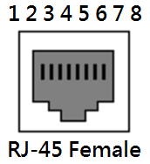
RJ-45 Ports (Auto MDI/MDIX)
The RJ-45 ports are auto-sensing for 10Base-T, 100Base-TX or 1000Base-T devices connections. Auto MDI/MDIX means that the switch can connect to another switch or workstation without changing the straight-through or crossover cabling. See the figures as below for straight-through and crossover cabling schematics.

10/100BASE-T(X) RJ-45 Pin Assignments (Table 2.2)
Crossover Cable |  | Straight Through Cable
Pin Number / Signal | Pin Number / Signal | Pin Number / Signal | Pin Number / Signal
1 / RX+ | 3 / TX+ | 1 / RX+ | 1 / TX+
2 / RX- | 6 / TX- | 2 / RX- | 2 / TX-
3 / TX+ | 1 / RX+ | 3 / TX+ | 3 / RX+
6 / TX- | 2 / RX- | 6 / TX- | 6 / RX-
Table 2.2

1000BASE-T RJ-45 Pin Assignments (Table 2.3)
Crossover Cable |  |  | Straight Through Cable
Pin Number / Signal | Pin Number / Signal | Pin Number / Signal |  | Pin Number / Signal
1 / TP0+ | 3 / TP1+ | 1 / TP0+ |  | 1 / TP1+
2 / TP0- | 6 / TP1- | 2 / TP0- |  | 2 / TP1-
3 / TP1+ | 1 / TP0+ | 3 / TP1+ |  | 3 / TP0+
4 / TP2+ | 7 / TP3+ | 4 / TP2+ |  | 4 / TP3+
5 / TP2- | 8 / TP3- | 5 / TP2- |  | 5 / TP3-
6 / TP1- | 2 / TP0- | 6 / TP1- |  | 6 / TP0-
7 / TP3+ | 4 / TP2+ | 7 / TP3+ |  | 7 / TP2+
8 / TP3- | 5 / TP2- | 8 / TP3- |  | 8 / TP2-
Table 2.3

Note: “+” and “-” signs represent the polarity of the wires that make up each wire pair.

Cabling
Use the two/four twisted-pair, category 5e, or the above cabling for RJ-45 port connections. The cable between the switch and the link partner (switch, hub, workstation, etc.) must be less than 100 meters (328 ft.) long.

Wiring the Power Inputs
Please follow the below steps to insert the power wire.
    - Insert the positive and negative wires into the PWR1 (V1+, V1-) and PWR2 (V2+, V2-) contacts on the terminal block connector as shown below in Figure 2.9.
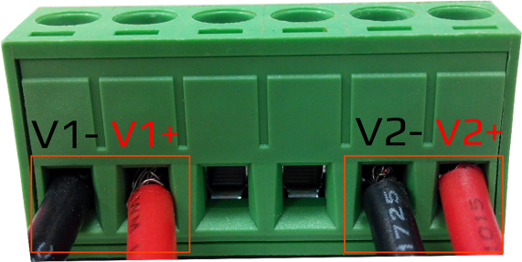
Figure 2.9: Power Terminal Block

    - Tighten the wire-clamp screws to prevent the wires from loosening, as shown below in Figure 2.10.
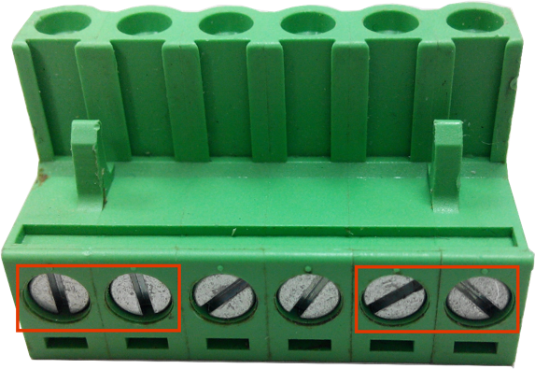
Figure 2.10: Power Terminal Block

Note: | Only use copper conductors, 60/75°C, tighten to 5 lbs.
 | The wire gauge for the terminal block should range between 18~20 AWG.

Wiring the Fault Alarm Contact
The fault alarm contact is in the middle of the terminal block connector as the picture shows below in Figure 2.11. By inserting the wires, it will detect the fault status including power failure or port link failure (managed industrial switch only) and form a normally open circuit. An application example for the fault alarm contact is shown below in Figure 2.11.

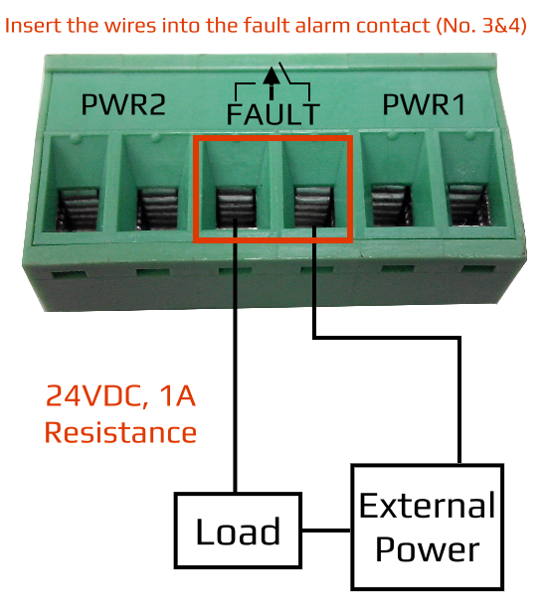
Figure 2.11: Wiring the Fault Alarm Contact

Note: | The wire gauge for the terminal block should range between 12 ~ 24 AWG.
 | If only using one power source, jumper Pin 1 to Pin 5 and Pin 2 to Pin 6 to eliminate power fault alarm.

Mounting Installation

DIN-Rail Mounting
The DIN-Rail is pre-installed on the industrial Ethernet switch from the factory. If the DIN-Rail is not on the industrial Ethernet switch, please see Figure 3.1 to learn how to install the DIN-Rail on the switch.
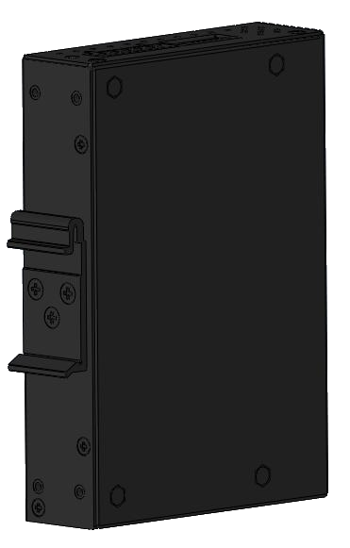
Figure 3.1: The Rear Side of the Switch and DIN-Rail Bracket

Follow the steps below to learn how to hang the industrial Ethernet switch.
      - Use the screws to install the DIN-Rail bracket on the rear side of the industrial Ethernet switch.
      - To remove the DIN-Rail bracket, do the opposite from Step 1.
      - After the DIN-Rail bracket is installed on the rear side of the switch, insert the top of the DIN-Rail on to the track as shown below in Figure 3.2.
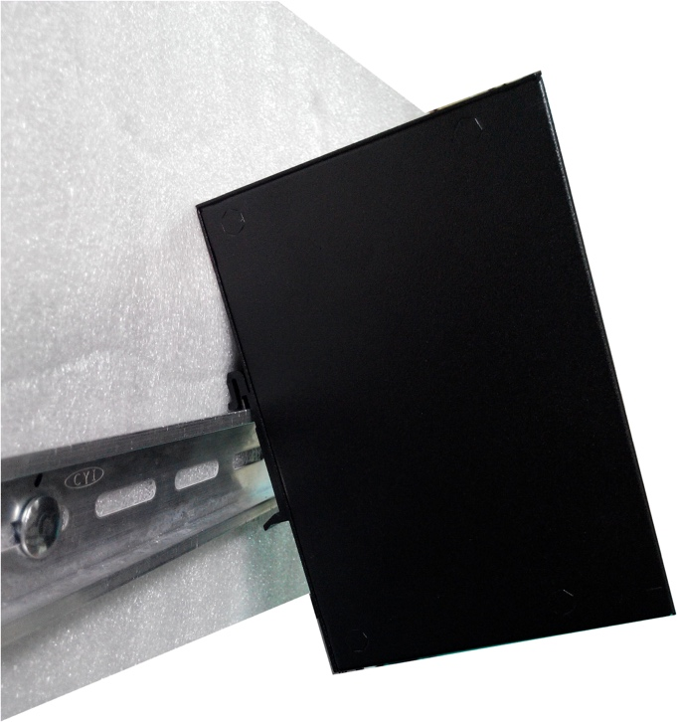
Figure 3.2: Insert the Switch on the DIN-Rail

      - Lightly pull down the bracket on to the rail as shown below in Figure 3.3.
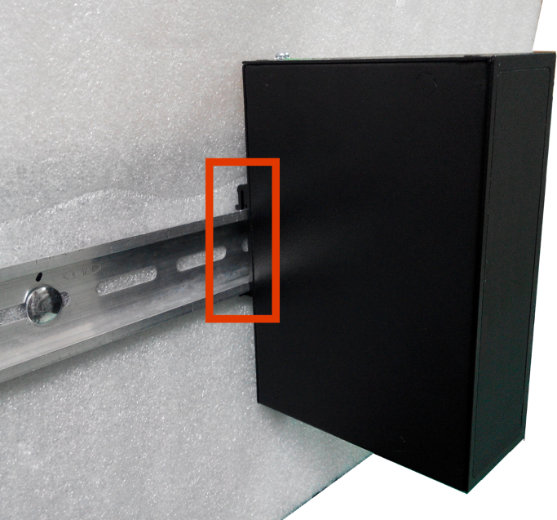
Figure 3.3: Stable the Switch on DIN-Rail

      - Check if the bracket is mounted tightly on the rail.
      - To remove the industrial Ethernet switch from the rail, do the opposite from the above steps.

Wall Mounting
Follow the steps below to mount the industrial Ethernet switch using the wall mounting bracket as shown below in Figure 3.4.
        - Remove the DIN-Rail bracket from the industrial Ethernet switch by loosening the screws.
        - Place the wall mounting brackets on the top and bottom of the industrial Ethernet switch.
        - Use the screws to screw the wall mounting bracket on the industrial Ethernet switch.
        - Use the hook holes at the corners of the wall mounting bracket to hang the industrial Ethernet switch on the wall.
        - To remove the wall mount bracket, do the opposite from the steps above.
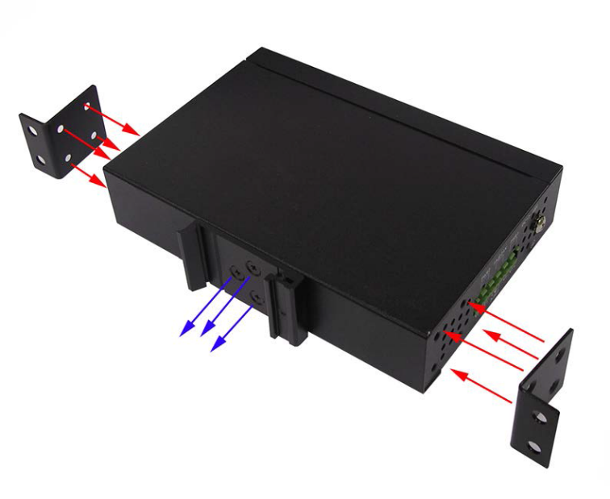
Figure 3.4: Remove DIN-Rail Bracket from the Switch

Below, in Figure 3.5 are the dimensions of the wall mounting bracket.
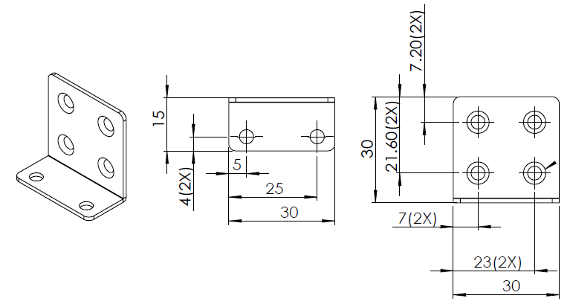
Figure 3.5: Wall Mounting Bracket Dimensions

Hardware Installation

Installation Steps
This section will explain how to install RPT-1005-X4 series:

Installation Steps
          - Unpack the industrial Ethernet switch from the original packing box.
          - Check if the DIN-Rail bracket is screwed on the industrial Ethernet switch.
- If the DIN-Rail is not screwed on the industrial Ethernet switch, please refer to the DIN-Rail Mounting section for DIN-Rail installation.
- If you want to wall mount the industrial Ethernet switch, please refer to the Wall Mounting section for wall mounting installation.
          - To hang the industrial Ethernet switch on a DIN-Rail or wall, please refer to the Mounting Installation section.
          - Power on the industrial Ethernet switch and then the power LED light will turn on.
- If you need help on how to wire power, please refer to the Wiring the Power Inputs section.
- Please refer to the LED Indicators section for LED light indication.
          - Prepare the twisted-pair, straight-through category 5 cable for Ethernet connection.
          - Insert one side of the RJ-45 cable into switch’s Ethernet port and on the other side into the networking device’s Ethernet port, e.g. switch PC or server. The Ethernet port’s (RJ-45) LED on the industrial Ethernet switch will turn on when the cable is connected to the networking device.
- Please refer to the LED Indicators section for LED light indication.
          - When all connections are set and the LED lights all show normal, the installation is complete.

Trouble Shooting

            - Verify you have the right power cord or adapter. Never use a power supply or adapter with a non-compliant DC output voltage or it will burn the equipment.

            - Select the proper UTP or STP cable in order to construct the network. Use an unshielded twisted-pair (UTP) or shield twisted-pair (STP) cable for RJ-45 connections: 100Ω Category 5e for 10M/100Mbps. Also be sure that the length of any twisted-pair connection does not exceed 100 meters (328 feet).

            - Diagnosing LED Indicators: To assist in identifying problems, the switch can be easily monitored with the LED indicators which help to identity if any problems exist.
              - Please refer to the LED Indicators section for LED light indication.

            - If the power indicator LED does not turn on when the power cord is plugged in, the user may have a problem with the power cord. Check for loose power connections, power losses or surges at the power outlet.
              - Please contact Sbjlink for technical support service, if the problem still cannot be resolved.

            - If the industrial switch LED indicators are normal and the connected cables are correct but the packets still cannot transmit, please check the system’s Ethernet devices’ configuration or status.

